Suggested software structure.

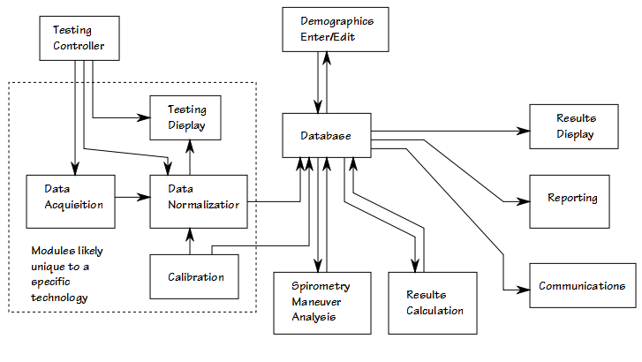
There are several possible configurations for an open spirometer.

Personal spirometer, stand-alone

Personal spirometer, results communicated to health care provider(s)/researcher(s)

Office/clinic spirometer, results stored locally

Office/clinic spirometer, results communicated to an umbrella organization

The long-term goal should be a single software product capable of runnning on smartphones, tablets or personal computers, that can be configured towards different purposes via user settings.

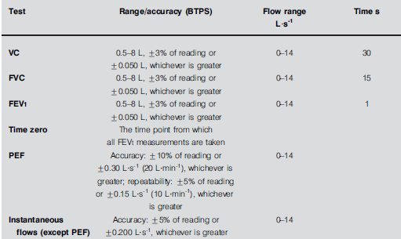ATS-ERS Minimum spirometer specifications
A. Data Acquisition

Raw data acquisition. Likely unique to a given measurement technology, for example:

- microphone

Breath sound analysis or fluidic oscillator.

- A/D converter

Pneumotach or hot-wire anemometer.

- Pulse counter

Turbine w/ optical pickup

Data rate will depend to some extent on the technology. Sampling theory concerning the frequency spectrum of respiratory signals (flow and volume, not breath sounds) recommends a minimum sampling rate of 30 hz. Faster is better to a certain degree and for this reason would actually recommend a minimum of 100 hz to a maximum of 1000 hz. Timing precision is important as integration and differentiation of raw data will only be accurate if the time interval between samples is precise.

One consideration is going to be whether the measuring device is directly or indirectly connected to the computer. A direct connection could be made via a USB connector and an indirect connection could be made via Bluetooth. The method of connection could act as a limiting factor for which type of system the spirometer could be attached to.

An additional consideration is the word length for raw data. The maximum values encountered during a spirometry maneuver given by the ATS-ERS +/- 8 liters and +/- 14 liters/second. This is conservative and +/- 10 liters and +/- 16 L/sec is a better goal. For A/D converters and equivalent processes a 10 bit word would limit accuracy to +/- 0.020 L and +/- 0.032 L/sec however this assumes that the entire dynamic range is used which is usually not be the case. Although this is nominally within ATS-ERS standards a single-bit error would put it outside. For this reason a minimum 12 bit word is recommended and a 16 bit word would likely be optimal.

B. Data normalization

Normalization is the conversion of raw data to flow and volume signals. This process will likely be unique to each given measurement technology. At a minimum the raw data signal must be adjusted for zero offset and gain. Since many measurement technologies are only approximately linear, this module must be able to convert a non-linear signal to a linear one. Linearization will likely depend on data obtained during a calibration procedure. Depending on the measurement technology raw data may also need to be corrected for gas density, temperature, viscosity. If the raw data is a flow signal then must be able integrate volume. If the raw data is a volume signal then must be able to differentiate flow. The measurement technology should be able to discriminate between positive (expiratory) and negative (inspiratory) flow. Output should be a single precision 2-D array of flow+volume at set time intervals

- Testing display.

This could either be an incentive display or a data display.

Incentive

Shows a representation of volume and/or flow and time. Volume and flow goals should probably be based on predicted values for the patient plus 25-50%. Should be used to show the subject that expiratory flow is still occurring and to get them to exhale for a minimum of 10 seconds.

Data:

Flow-volume loop and volume-time curve. Flow-time curve is not recommended because it is difficult to read.

- Testing controller

Manages raw data acquisition, data normalization and the testing display. Must be able to initiate testing mode and recognize beginning and the end of the test.

In order to simplify this process in the past some test systems have been oriented around an exhalation-only test maneuver. In these types of system the subject being tested takes a maximal inhalation then first places the mouthpiece in the their mouth and only then performs the maximal exhalation. Although this greatly simplifies the process of determining the beginning and end of the test maneuver studies have shown that FVC and FEV1 are always lower when measured this way.

More accurate testing occurs when the subject places the mouthpiece in their mouth first and only then performs the maximal inhalation and maximal exhalation. A problem with this approach is that the subject can perform one or more tidal breaths before performing the spirometry maneuver. For this reason there have been two general strategies for determining the beginning and the end of the actual spirometry test: operator controlled versus automatic.

The operator controlled strategy is easier to implement but requires practice and coordination on the part of the operator. Basically it requires the operator to do something (press a button etc) that tells the testing system that the next exhalation is the spirometry test.

The automatic strategy attempts to determine the beginning of the spirometry maneuver on its own and usually does so by using a threshold technique. Specifically, once a threshold expiratory flow rate has been exceeded, the testing module assumes that that particular exhalation is the spirometry test. The problem with this approach is that subjects can exceed a default threshold value during the tidal breathing phase or, when they are particularly debilitated, they may not be able to exceed the threshold value during the spirometry test. Automatic setting of a threshold is possible, but requires sampling a certain number of tidal breaths.

Once the beginning of the test has been recognized, the end of the test should be able to be automatically detected by:

- inspiratory flow occurring for longer than 1 (?) second

Exhalation should not be terminated as soon as any inspiratory flow is detected because when a subject coughs during exhalation short periods of inspiratory flow can occur. There needs to be a “grace” period during which the subject can be allowed to resume exhalation.

- zero expiratory flow for greater than 6 (?) seconds.

Expiratory flow can fall to zero when the subject has finished exhaling and comes off the mouthpiece so that no inspiratory flow is detected, during glottal closure or when no more exhalation is occurring despite continued patient effort. In any of these cases a 6 second period is more than enough time to wait to see if any more exhalation is going to occur.

- timout when more than 30 (?) seconds have elapsed.

The ATS-ERS recommends a minimum 6 second effort, but that is a minimum not a maximum. The ATS-ERS does state that efforts longer than 15 seconds are unlikely to be clinically useful. 30 seconds is certainly the longest that anyone can exhale.

- When an error has been detected in data acquisition.

Test mode should also be able to be terminated manually.

E. Spirometry manuever analysis

The normalized data array should consist of a 2D array of flow values in L/sec and volume values in liters with a known and consistent interval in fractional seconds between values. The flow signal values should be assumed to consist of accurate flow rates and should be positive (expiratory) or negative (inspiratory) relative to zero flow. The volume values should be accurate, but there may be a volume offset and all volumes should be re-calculated relative to a derived volume offset. It should be assumed that the normalized data array includes pre-test tidal breathing, the expiratory spirometry test maneuver and post-test inhalation. The apparent start of testing may be marked by the testing module but the actual spirometry maneuver must be confirmed and isolated.

Peak Expiratory Flow (PEF)

The assumption is going to be that the highest expiratory flow (PEF) in the entire array will be the marker for the spirometry maneuver. Since amplifier noise and single-bit errors can cause local spikes in the flow data, it is probably best to search using a rolling average and for reasons specified below, the average should be 80 milliseconds long (PEF80). The “real” PEF will be within the PEF80 averaging period and should be found and set aside for later reporting (PEFreal).

Determining the system volume at the beginning of exhalation.

The volume in the normalized data array may not be zero at the beginning of the spirometry maneuver. This can be due either to the use of a volume displacement spirometer as the measurement technique or to offsets in the integration of flow prior to this time. For this reason the zero volume offset must be determined. Using PEF80 as a marker, a rolling average backwards in time should be performed until the averaged flow signal is within the error bar for the zero flow signal (determined from prior calibration). The volume at this point will be averaged and becomes the volume offset (Voffset).

Determining start of exhalation with back-extrapolation

The start of the spirometry maneuver is never instantaneous. The standard ATS-ERS procedure to determine the “real” beginning of exhalation is to use the volume-time curve and to look for a the period of expiratory where the slope of the curve is both maximal and flat. This flat period is back-extrapolated to zero volume and the point at which it intersects is used as time zero. The ATS-ERS specifies averaging over an 80 millisecond period but does not have a defined counterpart in the flow signal.

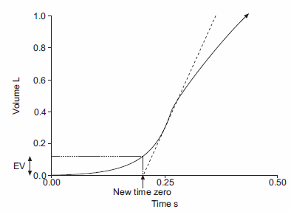
Strictly speaking the PEF80 is the maximum slope. The volume data point at the center of the 80 msec average has V volume and T time. The “real” zero point would then be determined by:

Tzero = T – ((V-Voffset)/PEF80)

The actual volume at the real zero time is considered to be the extrapolated volume (Vextrapolated) and will be used later in quality analysis of the spirometry effort.

Finding the end of the spirometry maneuver

The assumption is going to be that the highest volume following the PEF is going to be the end of exhalation. Although expiratory flow should be zero at this time, that cannot be assumed. Because of coughs, hesitations and glottal closures, expiratory flow can actually be negative (inspiratory) for short periods of time prior to the end of the spirometry maneuver. The maximum volume value can be found by searching forward through the normalized data array until either the maximum volume is found or the end of the array is encountered. This volume will be the FVC and the length of time from Tzero to this point will be the Total Expiratory Time (TET).

Determining timed values:

FEV1 = volume at Tzero+1 – volume offset
FEV3 = volume at Tzero+3 – volume offset
FEV6 = volume at Tzero+6 – volume offset

As long as the time interval is not greater than TET, otherwise the value will default to the volume at TET.

Other measured values:

There is a long list of possible measures that can be made from a spirometry effort. These include:

MIF @ 25, 50, 75: The inspiratory flow at 25%, 50% and 75% of the FVC
MEF @ 25, 50, 75: The expiratory flow at 25%, 50% and 75% of the FVC
FEV2
FEF25-75
FEF200-1200

These values are often included in commercial software but with the exception of FEF25-75 these are unused by all but a tiny handful of practitioners.

Quality assessment

The beginning of the spirometry maneuver should be assessed by the amount of volume extrapolation (Vextrapolation). Vextrapolation/FVC should be <5% or <0.15 L, whichever is larger.

The flow rate at TET should be less than 0.01 L/sec.

TET should be 6 seconds or greater.

The normalized data array should be assessed for pauses (periods of zero flow) following PEF. The length of each pause and when it occurs should be determined. Any pauses that start before the first second of exhalation will affect the FEV1 and the FEV1/FVC ratio.

F. Results calculation

Calculates predicted and percent predicted values for FEV1, FVC etc. using patient demographics. The GLFI reference equations are likely going to become the world standard for spirometry and will likely be the default recommendation of the ATS and ERS. This has not happened yet, and many physicians prefer older reference equations, so it might be considered necessary and/or desirable to offer a variety of reference equations. This option, however will add significant complexity to the testing system configuration and a reduction in cross-compatibility from one open spirometer system to another. An interim step would be to initially offer only a single set of reference equations and because the GLFI reference equations are very complicated, use the NHANESIII instead.

G. Results display

Must be able to displays all numerical and graphical results after each test. Numerical results for all test efforts can likely be placed in a single table (although this implies an upper limit to the number of efforts performed/displayed within a single testing session).

Graphical results (flow-volume loop and volume-time curves) require significant display real estate. Results could be displayed one effort at a time or be overlapped. Overlapping results should be a user selected option (i.e. selecting which results are overlapped) since overlapped results can be difficult to understand.

This module should also be used to select which results are going to be reported. The “best” single effort is considered to be the one with the highest combined FVC+FEV1 however ATS-ERS standards also allow for reporting FVC and FEV1 from different test efforts (highest FVC always, largest FEV1 from an acceptable quality test). There should be an automatic selection process that can be overridden by the user.

H. Demographics

Enter/edit patient identity, DOB, height, gender, ethnicity. Stores/retrieves data to/from the database.

Patient identity will be important whenever results are going to be communicated or when the spirometer is used by more than one subject. Identification numbers are usually assigned by health care/research organizations but a given patient may have multiple identification numbers. The ability to enter and manage multiple identification numbers will likely be necessary.

- Database

Relational, SQL (MariaDB? MySQL?). Files for demographics, numerical spirometry data, raw/graphical spirometry data, calibration data, configuration data. A testing session for a single individual contains one demographic record and one or more paired results+data records. Calibration and configuration records exist separately and belong to the testing system, not to an individual or a testing session.

Demographics:

Identification number(s)
Last name
First Name
DOB
Gender
Ethnicity

Testing Session

Subject height
Weight (optional)
Session date/time

Spirometry results, numerical

Date/time (must match a corresponding raw data record)
Reported (only one record from a session can say yes)
Composite or real
FVC
FEV1
FEV1/FVC
FEV3
FEV3/FVC
FEV6
FEV1/FEV6
PEF
TET

Spirometry results, raw data

Date/time (must match a corresponding numerical results record)
Data time interval (fractional seconds)
Normalized data array

Calibration data

Date/time
Data unique to a specific measurement technique

Report configuration

Demographic elements
Numerical results
Graphic panels
Trends

Communications configuration

LOINC cross-references
Subject identity configurations
Email addresses

J. Communications

Using C-CDA standards and HL7 communication protocols. Transfers data to physician, clinic, hospital or research organization. Some systems use an email-type protocol for this so will require an internet connection while others require the receiving end be on the same LAN.

K. Paper/PDF reports

Demographics
Numerical data
Graphical data
Trends

- Calibration.

Likely unique to each testing technology. Assess zero offset and gain. Assess non-linearity. Generate data needed to normalize raw data.

